Micro-Project Annexure-1

Course Title: Mobile Application Development

Course Code: 316006

Under the Guidance of: Mrs. Sowmya Swamy

Topic: Smart Alarm



Group Members:

Roll No. | Enrollment No. | Name
1 | 23150930440 | Avdhut Madhavi
2 | 23150930448 | Sneha Sagale

1.0 Aims/Benefits of the Micro-Project:
Aims
- To design and develop a Smart Alarm mobile application that helps users wake up on time using interactive alarm features.
- To implement features like math problems, reminders, and notifications to ensure the user actively stops the alarm.
- To integrate additional functionalities such as weather updates and location-based reminders.
- To create an alarm system that improves daily routine management and productivity.
Benefits
- Helps users wake up more effectively and reduces the habit of snoozing alarms.
- Encourages mental activity in the morning through tasks like solving math problems to turn off the alarm.
- Improves time management and daily routine planning using reminders and habit tracking.
- Enhances the user’s discipline and productivity by promoting consistent wake-up habits.

2.0 Course Outcomes Addressed:
CO1 - Interpret the features of android operating system.
CO2 - Use after configuring Android development environment.
CO3 - Develop android applications using UI components and layouts.
CO4 - Create database driven Android applications.
CO5 - Develop advanced Android applications that requires relevant permissions for security.

- Proposed Methodology:
- Requirement Analysis
Identify the requirements of the Smart Alarm application such as alarm functionality, emergency contact notification, weather updates, timer, stopwatch, time conversion, and user authentication.
- System Design
Plan the overall structure of the application and divide it into modules like splash screen, login and registration, alarm system, weather module, and utility tools.
- User Authentication Implementation
Develop the login and registration system to allow users to securely access the application and store their details.
- Alarm and Notification System
Implement the alarm feature where the user can set alarms and stop them when they wake up.
- Emergency Contact Feature
Add a feature that sends a message to the selected emergency contact confirming that the user is awake along with the wake-up time.
- Additional Utility Features
Implement useful tools such as weather updates, timer, stopwatch, and time zone conversion (IST to EST and EST to IST).
- Testing and Evaluation
Test all modules of the application to ensure proper functionality and evaluate the overall performance of the Smart Alarm system.

4.0 Action Plan:

Sr. No. | Details of the Activity | Planned  Start Date | Planned Finish Date | Name of the responsible Team Members
1 | Topic Selection | 05-Jan-26 | 07-Jan-26 | Avdhut Madhavi,  Sneha Sagale
2 | Annexure 1 submission | 08-Jan-26 | 13-Jan-26 | Avdhut Madhavi,  Sneha Sagale
3 | Information Search | 14-Jan-26 | 28-Jan-26 | Avdhut Madhavi,  Sneha Sagale
4 | Making rough programs | 01-Feb-26 | 10-Feb-26 | Avdhut Madhavi,  Sneha Sagale
5 | Final presentation of programs | 11-Feb-26 | 21-Feb-26 | Avdhut Madhavi,  Sneha Sagale
6 | Annexure 2 submission | 23-Feb-26 | 28-Feb-26 | Avdhut Madhavi,  Sneha Sagale
5.0 Resources Required:

Sr. No. | Name Of Resource | Specification | Quantity | Remarks
1 | Laptop | 8GB RAM, 256GB SSD, Intel i3 | 1 | -

Micro-Project Annexure-2

Course Title: Mobile Application Development

Course Code: 316006

Under the Guidance of: Mrs. Sowmya Swamy

Topic: Smart Alarm



Group Members:

Roll No. | Enrollment No. | Name
1 | 23150930440 | Avdhut Madhavi
2 | 23150930448 | Sneha Sagale

- Aims/Benefits of the Micro-Project:

Aims
- To design and develop a Smart Alarm mobile application that helps users wake up on time using interactive alarm features.
- To implement features like math problems, reminders, and notifications to ensure the user actively stops the alarm.
- To integrate additional functionalities such as weather updates, habit tracking, and location-based reminders.
- To create an alarm system that improves daily routine management and productivity.

Benefits
- Helps users wake up more effectively and reduces the habit of snoozing alarms.
- Encourages mental activity in the morning through tasks like solving math problems to turn off the alarm.
- Improves time management and daily routine planning using reminders and habit tracking.
- Provides useful information such as weather updates and notifications to help users plan their day better.

2.0 Outputs of the project:

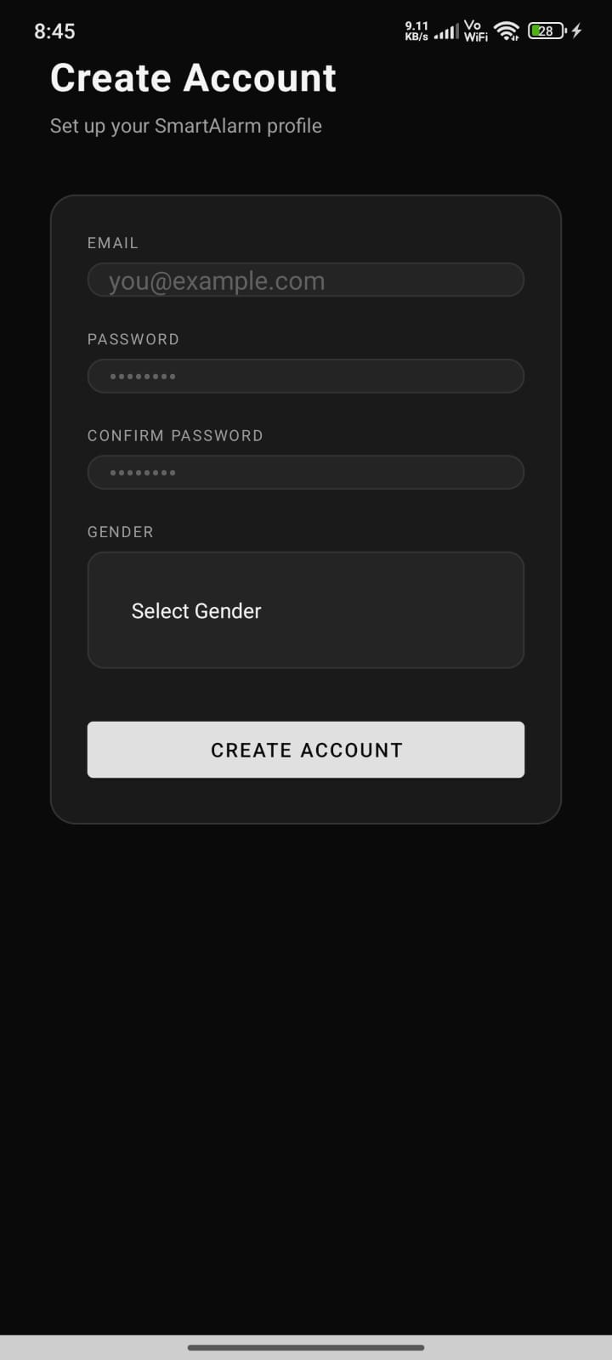
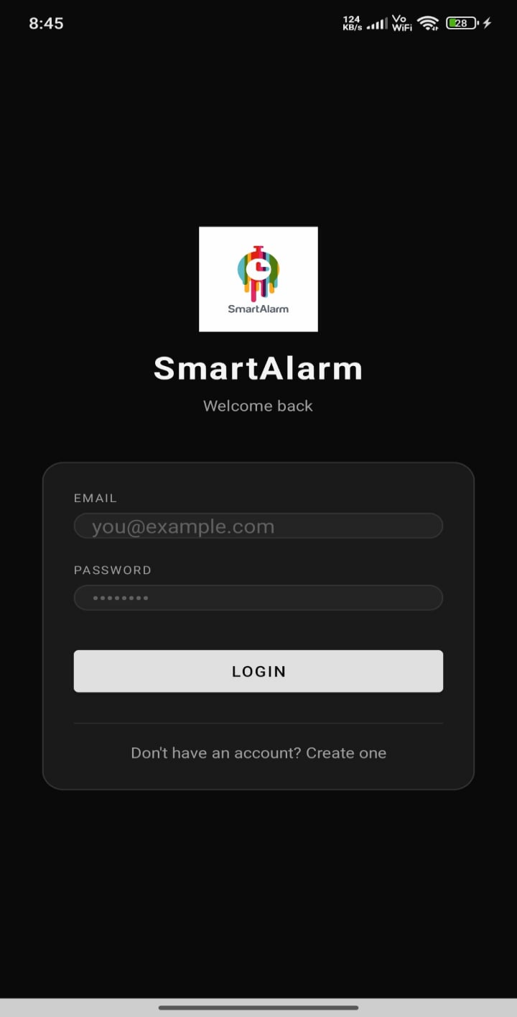
LOGIN PAGE SIGN UP PAGE

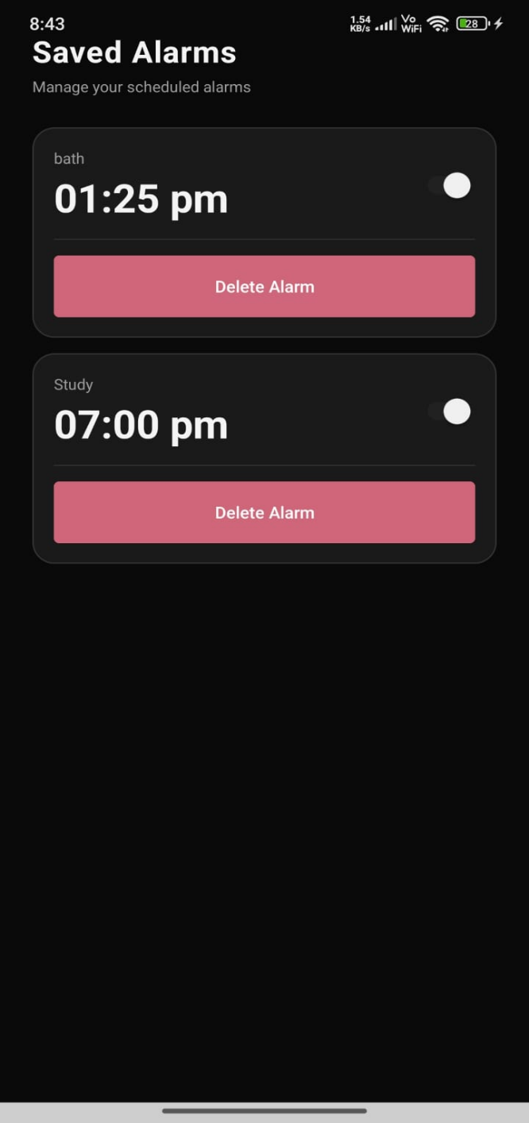
HOME PAGE SAVED ALARMS
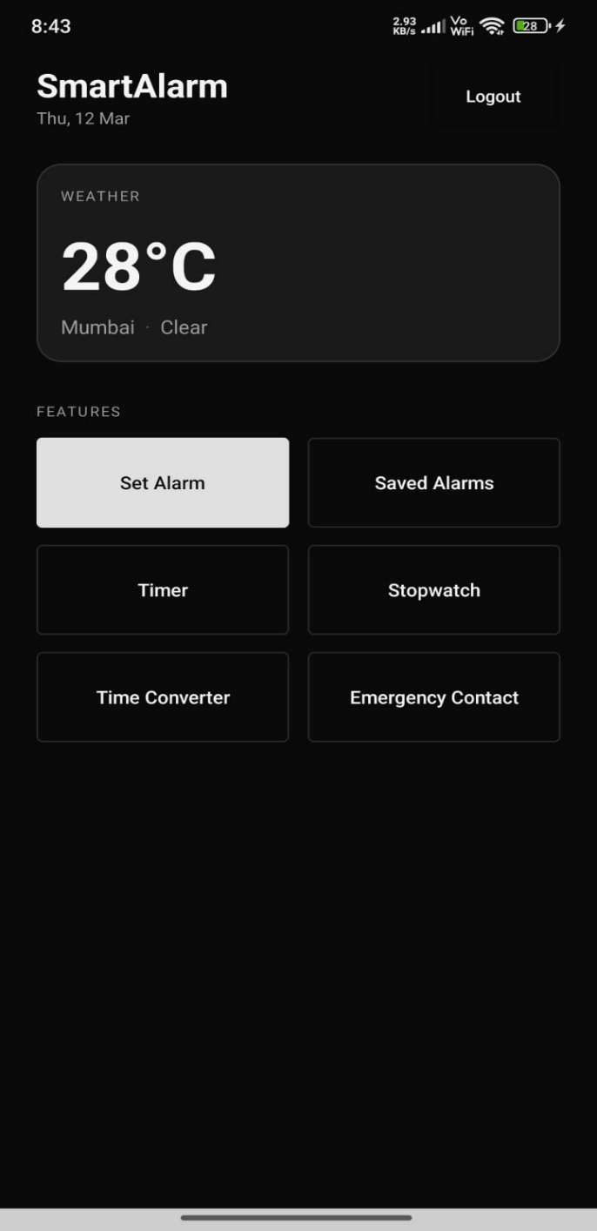

TIMER STOPWATCH
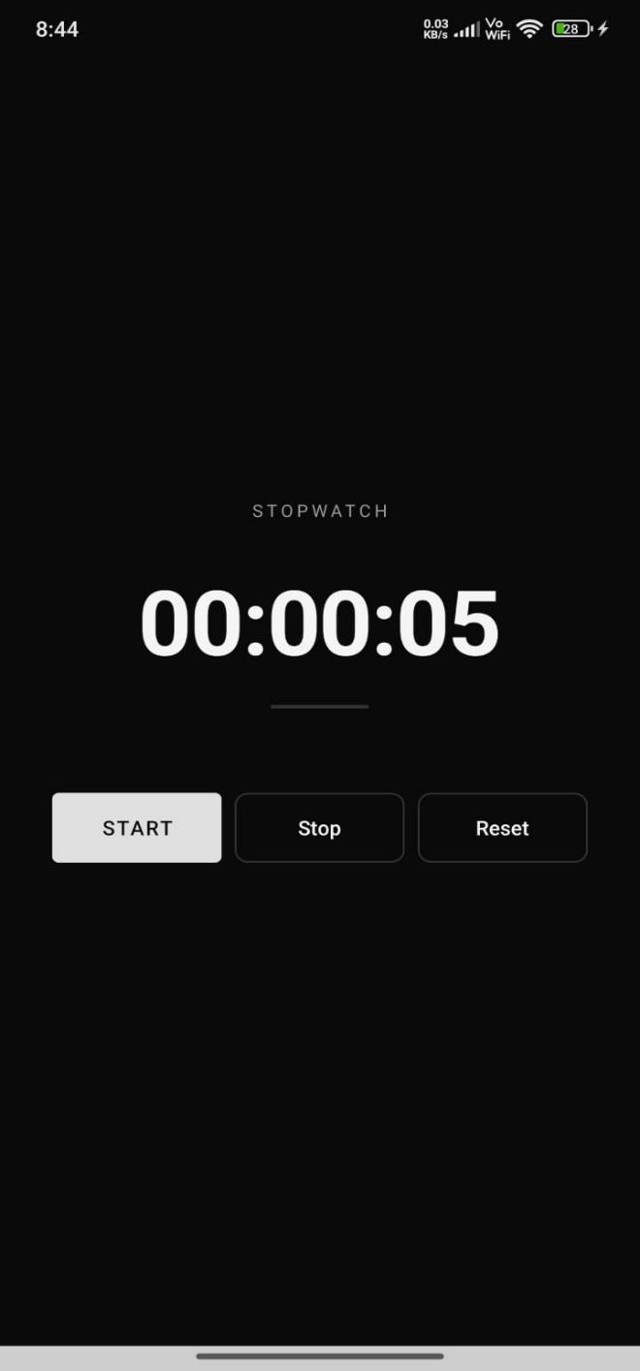
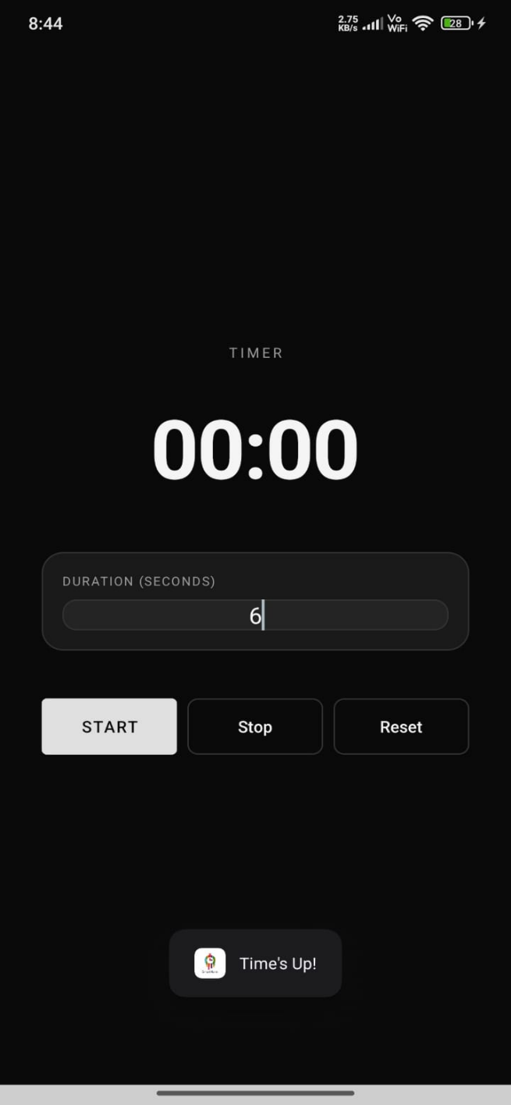

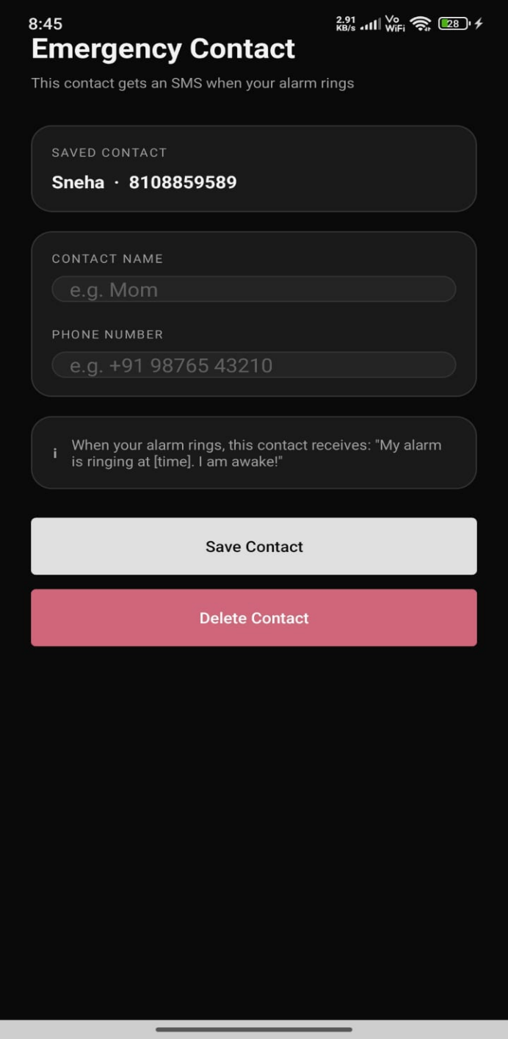
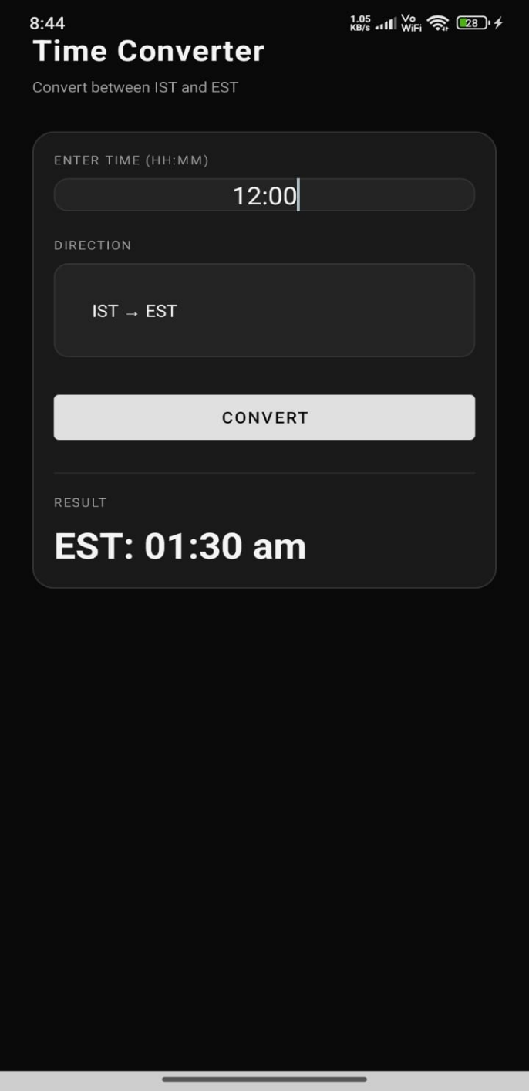
TIME CONVERTER EMG. CONTACT

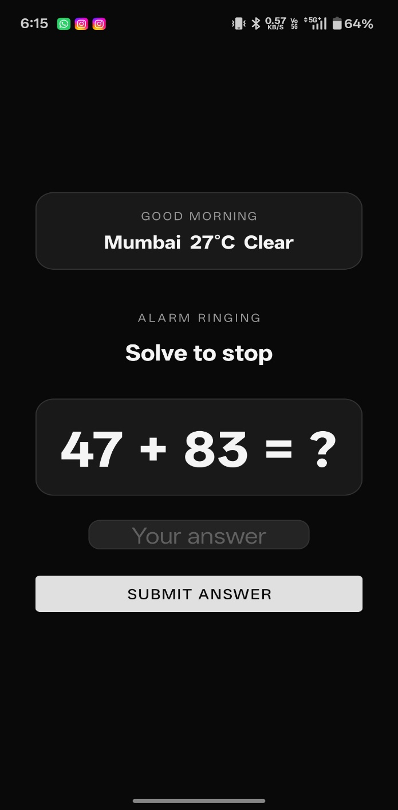
EMG. MESSAGE MATH EQUATION
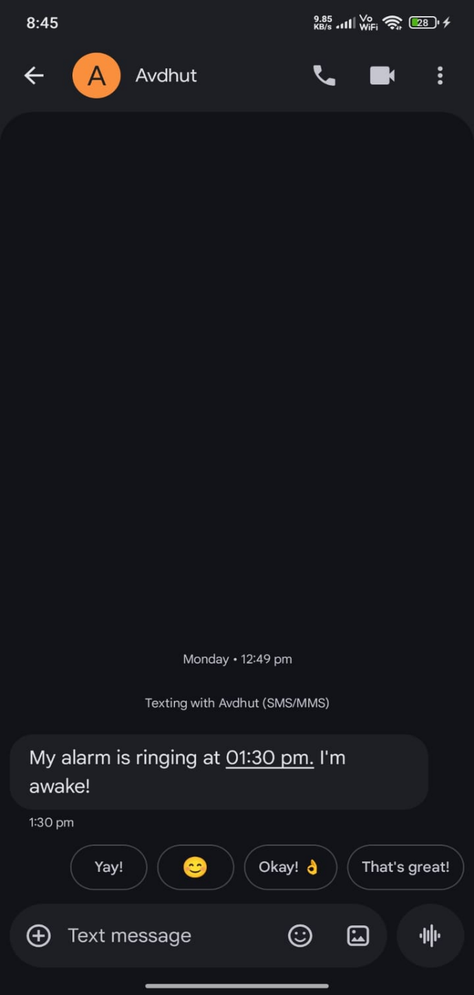

FLYER

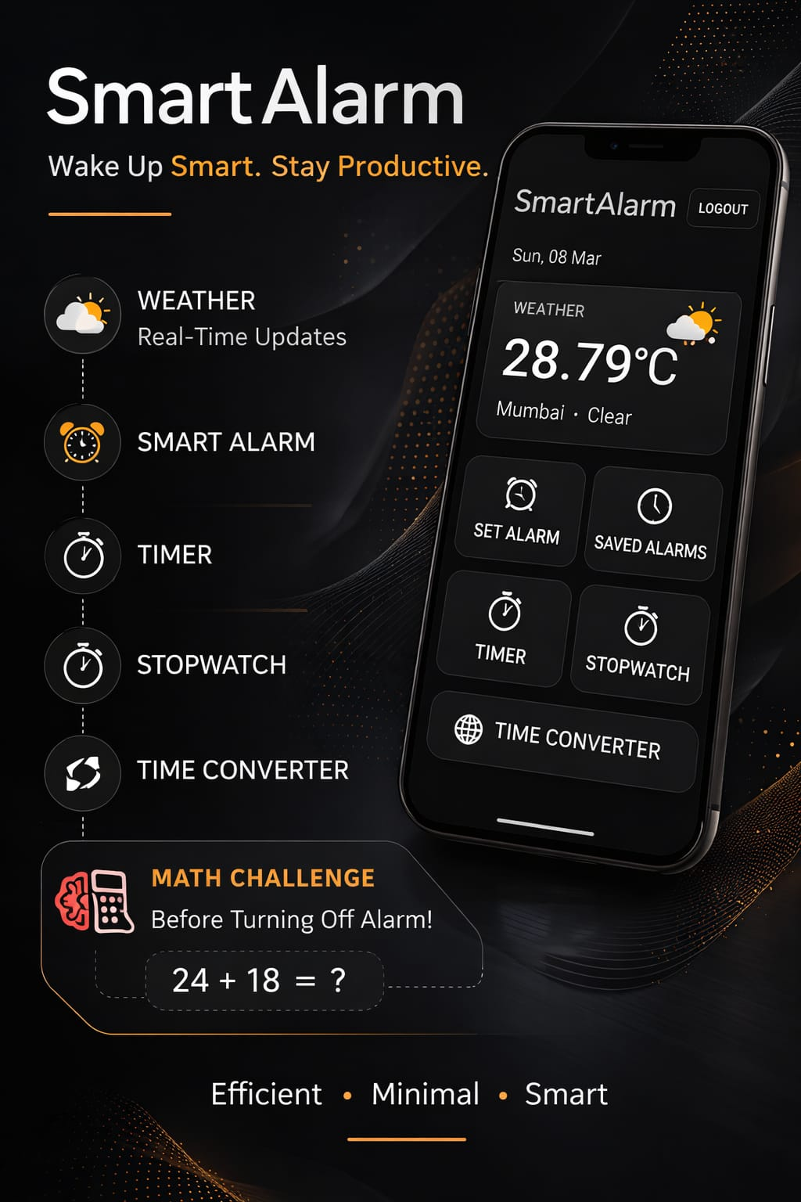

- Skills developed/Learning out of this Mirco-Project

- Mobile App Development Skills
Gained experience in designing and developing a mobile application with multiple functional modules.
- User Interface (UI) Design
Learned how to create a simple and user-friendly interface including splash screens, login pages, and feature layouts.
- Programming and Logical Thinking
Improved coding ability and logical thinking while implementing features like alarm functionality, timer, and stopwatch.
- API Integration
Developed skills in integrating external services such as weather information into the application.
- Database and Authentication Handling
Learned how to implement login and registration systems for managing user data securely.
- Problem Solving and Debugging
Improved the ability to identify errors and fix issues during the development and testing stages.
- Project Planning and Feature Integration
Gained experience in organizing different modules and integrating them into a complete working application.

4.0 Conclusion

The Smart Alarm application was developed to help users wake up on time and manage their daily routine. It includes features such as alarm notifications, emergency contact messaging, weather updates, timer, stopwatch, and time zone conversion. The project demonstrates how multiple useful features can be integrated into a single mobile application and helps improve productivity and time management.

